NAME:VENKATRAMAMOORTHY.G
- Create a simple webpage that displays three sections, each styled using a different CSS method:
Inline CSS:
Inline CSS is written directly inside an HTML tag using the style attribute.
Example:
<p style="color: red;">This is inline CSS</p>
Internal CSS:
Internal CSS is written inside a <style> tag in the <head> section of an HTML page.
Example:
<style>
p {
color: blue;
}
</style>
External CSS:
External CSS is written in a separate .css file and linked to HTML.
Example:
<link rel="stylesheet" href="styles.css">
OUTPUT:
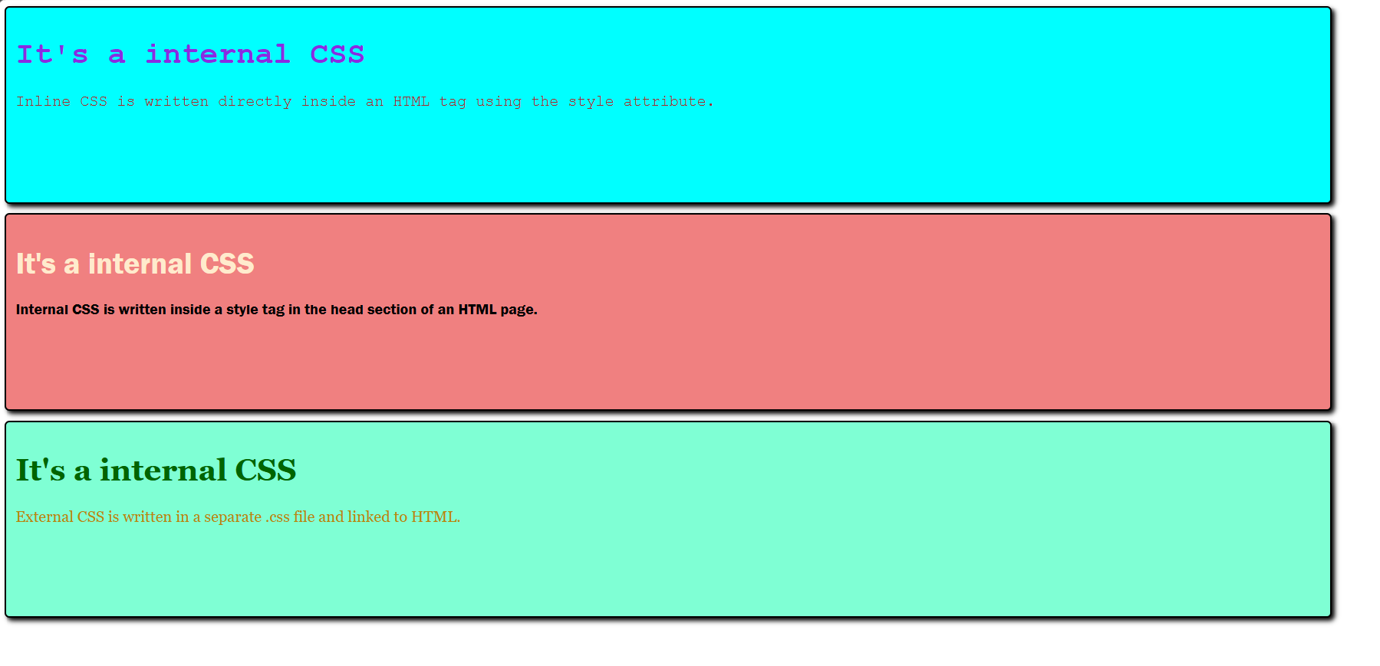
- i)Three sections are styled correctly using different methods.
ii)External stylesheet is linked properly and loads without errors.
iii)The layout and styling clearly differentiate the three CSS types.
CODE:
<!DOCTYPE html>
<html lang="en">
<head>
<meta charset="UTF-8">
<meta name="viewport" content="width=device-width, initial-scale=1.0">
<title>Document</title>
<link rel="stylesheet" href="style.css">
<style>
.internal{
background-color: lightcoral;
height:25vh; width: 90%;
margin-bottom: 10px;
padding: 10px;
border: 2px solid black;
border-radius: 5px;
box-shadow: 3px 3px 5px;
font-family: 'Franklin Gothic Medium', 'Arial Narrow', Arial, sans-serif;
}
.h1{
color: blanchedalmond;
}
p1{
color: aquamarine;
}
</style>
</head>
<body>
<section style="background-color: aqua; height:25vh; width: 90%; margin-bottom: 10px;padding: 10px;border: 2px solid black; border-radius: 5px; box-shadow: 3px 3px 5px;">
<div style="font-family: 'Courier New', Courier, monospace;color: blueviolet;">
<h1>It's a internal CSS</h1>
<p style="color:brown">Inline CSS is written directly inside an HTML tag using the style attribute. </p>
</div>
</section>
<section class="internal">
<h1 class="h1">It's a internal CSS</h1>
<p class="p1">Internal CSS is written inside a style tag in the head section of an HTML page.</p>
</section>
<section id="external">
<h1 id="h1">It's a internal CSS</h1>
<p id="p1">External CSS is written in a separate .css file and linked to HTML.</p>
</section>
</body>
</html>
CSS:
#external{
background-color: aquamarine;
height:25vh; width: 90%;
margin-bottom: 10px;
padding: 10px;
border: 2px solid black;
border-radius: 5px;
box-shadow: 3px 3px 5px;
font-family: Georgia, 'Times New Roman', Times, serif
}
#h1{
color: darkgreen;
}
#p1{
color: darkgoldenrod;
}
OUTPUT:


